My brain

1. 2π(r+1) - 2πr = x

2 π (r+1-r) = x

x = 2 π Apvaliname π iki dviejų skaičių po kablelio π = 3.14

x= 6.28

2.

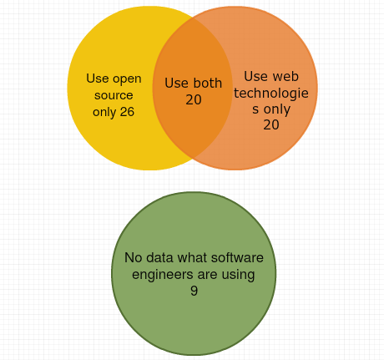

3.

|  |  |  |  |  |  |
| --- | --- | --- | --- | --- | --- |
|  | Ana | Bob | Charlie | Diana | Ebbe |
| Language | C# | Javascript | Python | SQL | Java |
| Floor | 2 | 1 | 3 | 4 | 5 |